18.59: 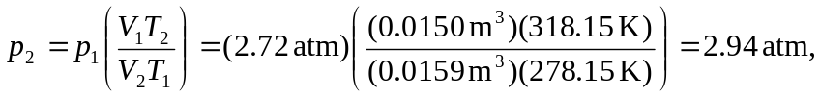

so the gauge pressure is 